**SCS 2209 – Tutorial 5**



Create procedure for get all supplier details.

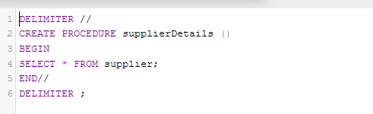

After calling the function,

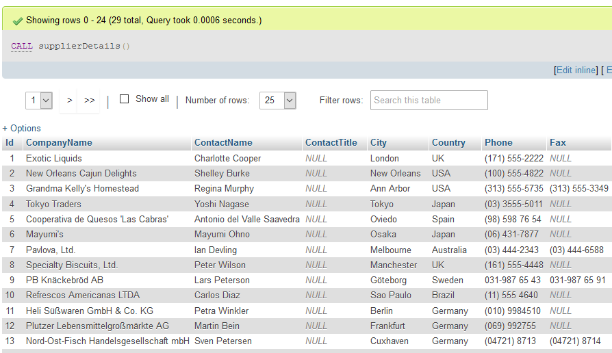

1. Create procedure for the get suppliers details from given country.

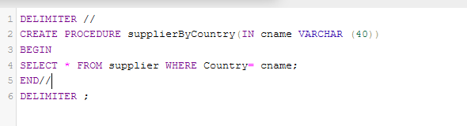

After calling the function with given country,

Eg: UK

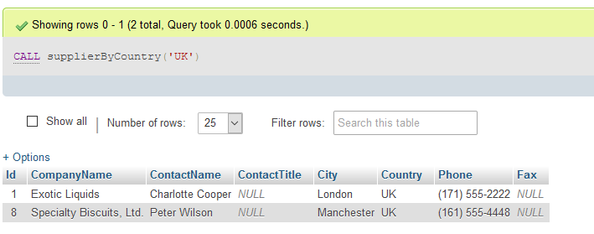

1. Create procedure for get phone number of given supplier company

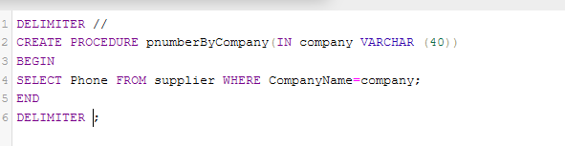

After calling the function with given company name,

Eg: Tokyo Traders

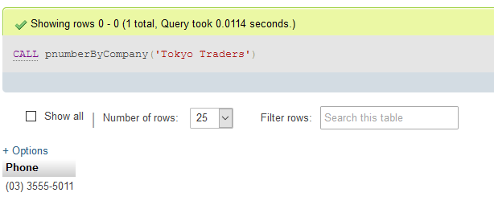

1. Create procedure for the get rating value for the given unit price of product.

UnitPrice > 100 🡪 High

100>= UnitPrice >=50 🡪 Medium

UnitPrice < 50 🡪 Low

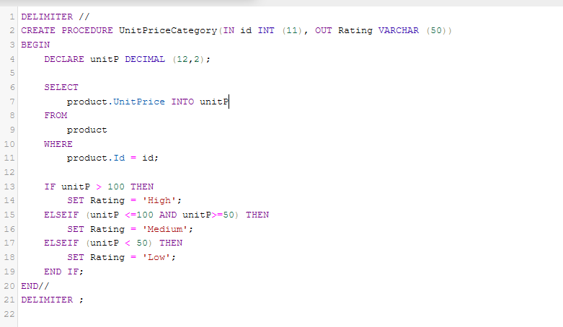

2. Create procedure called ‘OrderItemCount’ for the get item count under given order id.

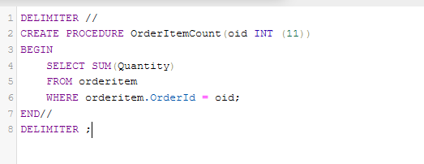

For eg: item count in order id 1 (call the function with order id 1)

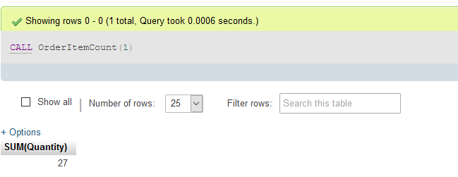

item count in order id 2 (call the function with order id 2)

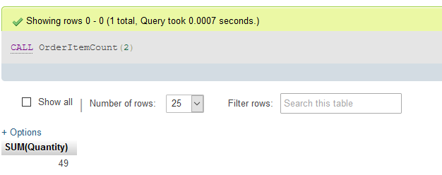



* To help you build powerful database applications, stored procedures provide several advantages including better performance, higher productivity, ease of use, and increased scalability.
* Additionally , stored procedures enable you to take advantages of the computing resources of the server.